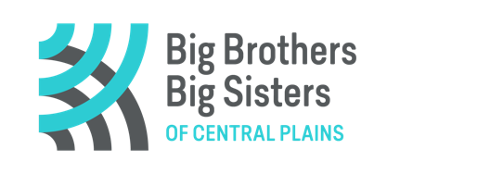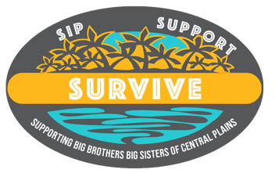

REGISTRATION FORM!

**HOW TO REGISTER**

You must fill in the required team information below. Each team must purchase a minimum of 4 tickets. however, you can list names multiple times to make up four participants slots.

The team fee is $100 ($25 per participant). Payment can be provided with credit card, e-transfer to: [dawn.froese@bigbrothersbigsisters.ca](mailto:dawn.froese@bigbrothersbigsisters.ca) or drop off cash/cheque at the BBBS Office 15 Tupper St. S., Portage la Prairie (west purple door).

**SEND COMPLETED REGISTRATION FORM TO: dawn.froese@bigbrothersbigsisters.ca**

**TEAM NAME: __________________________________. Phone# __________________________**

**TEAM PARTICIPANTS:**

**1.Captain:_____________________________ EMAIL _________________________ Tic# _____**

**2. _______________________________________EMAIL _________________________ Tic# _____**

**3._______________________________________ EMAIL _________________________ Tic# _____**

**4. ______________________________________ EMAIL _________________________ Tic# _____**

Credit Card Info: Name on Card: _______________. Number: ______________________

Expiry Date: ________________. CVC ________. Total Amount: ___________

Postal Code ________

**I would like to purchase a Bonus Ticket for my team($40 additional) Yes No**

**HOW TO WATCH….**with your drink (whatever that may be)

Once registered, an email will be sent providing the link to join the closed Sip, Support and Survive Facebook Group. Eliminations will be done live and posted on the Facebook Group page as well on the website.

Registration and payment deadline: Sunday, Feb. 23, 2025 4:00 pm

The elimination draws Monday February 24th until Friday March 7st; 12:15pm M-F (except Feb. 28)

Please do not hesitate to reach out with any questions: [dawn.froese@bigbrothersbigsisters.ca](mailto:dawn.froese@bigbrothersbigsisters.ca)

License# LGCA 5602-RF-46590