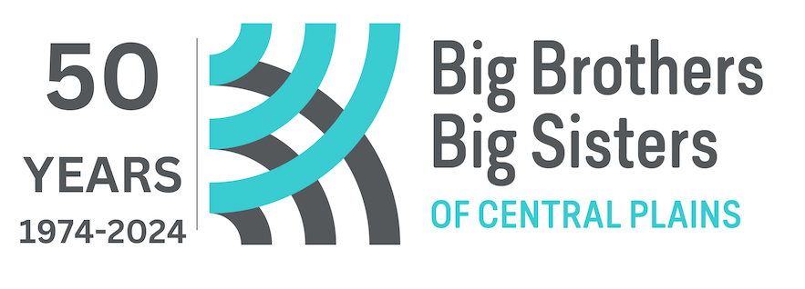 the ULTIMATE 90 Hole Golf Marathon
PleC Info to volunteer. ___

Info for Board ___

________________________ _____________________________ ___________________ ____________________________
Golfer’s Name Email Day Time Phone Company Name

Sponsor’s Name (Please Print Clearly) | Address (full address required for all tax receipts) | City | Prov. | P.C. | Email to receive receipt on line | Paid Pledges | On line  Pledges
Total Pledges

Fundraising Goal ____________________. Total ___________

Your email will not be sold or given to anyone else. It will be used for BBBS Central Plains only.
2024

