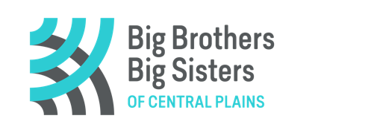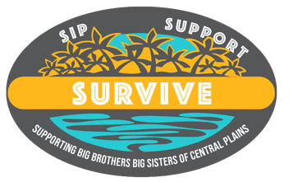

REGISTRATION FORM!
HOW TO REGISTER
You must fill in the required team information below. Each team must purchase a minimum of 4 tickets. however, you can list names multiple times to make up four participants slots.

The team fee is $100 ($25 per participant). Payment can be provided with credit card by phone 204 857-4397 or via e-transfer to: dawn.froese@bigbrothersbigsisters.ca or drop off cash/cheque at the BBBS Office 15 Tupper St. S., Portage la Prairie (west purple door).

SEND COMPLETED REGISTRATION FORM TO: dawn.froese@bigbrothersbigsisters.ca

TEAM NAME: __________________________________. Phone# __________________________
TEAM PARTICIPANTS:
1.Captain:__________________________________ EMAIL ________________________________
2. ___________________________________________ EMAIL ________________________________
3.____________________________________________ EMAIL ________________________________
4. ___________________________________________ EMAIL ________________________________

I would like to purchase a Bonus Ticket for my team($40 additional) Yes No
HOW TO WATCH….with your drink (whatever that may be)
Once registered, an email will be sent providing the link to join the closed Sip, Support and Survive Facebook Group & a link for zoom(if you don’t have facebook). Eliminations will be done live and posted on the FacebookGroup. Eliminated names will be listed on the website.

Registration and payment deadline: Sunday February 5, 2023 4:30 pm
The elimination draws will start Monday, February 6th until Friday February 17th; Monday - Friday at 12:15 pm
Please do not hesitate to reach out with any questions: dawn.froese@bigbrothersbigsisters.ca

Gaming License#LGCA 5602-RF-39680

